**Customer Analytics Winter 2022**

**Professor Scott Neslin**

**Blue Apron:**

**Turning Around the Struggling Meal Kit Market Leader\***

In 2016, Blue Apron was the leading meal kit delivery business in the United States. To finance future growth, management decided to embark on an initial public offering (IPO) in 2017.

The registration form Blue Apron filed for the IPO showed a successful business in a rapidly growing industry.[1] Experts expected the industry to grow rapidly in the years to come. Blue Apron held a commanding 53% market share.

But signs developed that pointed to long-term troubles for Blue Apron. The cost of acquiring customers was increasing. Worse, newly acquired customers generated a lower revenue stream, on average, than those acquired earlier in the company’s history.

Blue Apron went public (NYSE: APRN) on June 29, 2017. The IPO received significant media attention, but a mixed market reaction. The price was $10 per share, well below the company’s target of $15 to $17. Over the next five months, Blue Apron’s stock price dropped 70%. On Nov. 30, 2017, with the stock price trading at $2.99, CEO Matt Salzberg resigned.

Brad Dickerson, Blue Apron’s former CFO, stepped in as the new CEO. He faced a formidable turnaround task. Just how valuable were Blue Apron’s current customers? How should Blue Apron manage its customer relationships to improve profitability?

**Leading a High-Growth Industry (2014-2017)**

The meal kit delivery services industry consisted of companies that market, sell, and deliver packages of fresh ingredients for one or more meals directly to consumers, with step-by-step instructions to prepare the meals at home.

Estimates pegged the U.S. meal kit delivery industry at $4.65 billion in 2017, up from $1.5 billion one year earlier.[2] Experts forecasted it would grow at a 20% annual rate through 2022.

Most meal kit delivery companies operated on a subscription basis, with customers paying a weekly fee for meals. Blue Apron offered two subscription plans: one meant for two people, in which each week customers received an order consisting of six servings at $9.99 per serving, and another meant for families, in which an order consisted of 16 servings at $8.74 per serving. Once the customer signed up for one of these plans, Blue Apron delivered the appropriate number of servings each week unless the customer asked to skip the order that week or cancelled the subscription (“churned”).

Meal kit companies ordered raw ingredients to their distribution facilities and prepared them so everything required for the meal was included in one box. A kit might contain half of one red bell pepper, for example. Companies used ice packs and insulating materials to ensure ingredients were kept at temperatures to meet food safety standards.

Some companies catered to specific customer preferences: Purple Carrot, Green Blender, and PeachDish delivered vegan meals, smoothies, and U.S. southern cuisine, respectively.

The larger companies did not specialize. However, market leaders Blue Apron and HelloFresh were expanding into breakfast kits, lunch kits, and complementary products (e.g., wine). Complementary product sales were small but expected to grow.

In 2016, Blue Apron held the highest market share, 53% (see **Exhibit 1**). This was almost three times its next closest competitor, HelloFresh.[3] Despite intense and increasing competition, the latest figures indicated Blue Apron was able to sustain a 40% market share in 2017.[4]

**Exhibit 1  
U.S. Meal Kit Company Market Share – 2016**

|  |  |  |  |  |
| --- | --- | --- | --- | --- |
| **Company** | **Meal Specialization** | **Market Share** | | **Price Per Serving[5]** |
| Blue Apron | General | 53% | $9.99 | | |
| HelloFresh | General | 20% | $9.99 | | |
| Home Chef | General | 6% | $9.99 | | |
| Plated | General | 5% | $12.00 | | |
| Green Chef | Organic, Gluten Free | 3% | $11.99 | | |
| Sun Basket | General | 3% | $12.49 | | |
| Purple Carrot | Vegan | 1% | $12.00 | | |
| Gobble | Fast Preparation | 1% | $11.95 | | |

*Source: Created by the case writers with data from company websites and Second Measure.*

**Acquiring New Customers**

Blue Apron’s generated approximately $800 million in sales in 2016, tenfold growth over 2014.[6] Growth was driven primarily by an increase in Blue Apron’s subscriber base. The company’s total number of active customers more than doubled in 2016, growing to nearly 900,000 by the fourth quarter.

Blue Apron used a combination of offline media, online media, and a referral program to attract new customers. As the company ramped up its marketing spend, offline campaigns accounted for roughly half of Blue Apron’s marketing spend (**Exhibit 2**).

**Exhibit 2   
Blue Apron 2014-2016 Marketing Expenditure (in $MM)**

|  |  |  |  |
| --- | --- | --- | --- |
|  |  |  |  |
|  | **2014** | **2015** | **2016** |
| Offline Media | 2 | 18 | 66 |
| Online Media | 5 | 15 | 43 |
| Customer Referral Program | 7 | 18 | 35 |
| Total Marketing Expense | 14 | 51 | 144 |

*Source: Blue Apron S-1 Filing 2017.*

Offline media consisted mostly of TV and radio. Online media included banner ads, paid search ads, social media campaigns, video ads, podcasts and streamed radio.

For example, the company produced video ads and sponsored YouTube personalities.[7] The company experimented with native advertising, such as sponsoring pieces on Buzzfeed. (See **Appendix A** for advertisement examples.)

Naturally, Blue Apron’s marketing costs grew. Because of the investments it made, the firm’s profitability was roughly flat in 2016. Blue Apron argued its investments, especially into a new state-of-the-art distribution facility in Linden, N.J., positioned the company for success as the meal kit delivery industry continued to grow.

Veronica Thomas, Blue Apron’s CMO, discussed Blue Apron’s marketing with Mr. Dickerson: She informed him, “I focus on three decisions:

* Message
* Channel
* Incentives

Our message originally focused on easy preparation and convenience. More and more, however, we’re offering ‘$X off’ and making that message prominent. Just a few years ago, we never mentioned price in our acquisition campaigns. Starting around 2015, I’d say roughly half the customers we acquired took advantage of financial incentives in order for them to agree to sign up, and I bet this percentage is growing. We’re just responding to competition **(Appendix B)**, so these incentives are necessary, but I am not sure exactly what they’re getting for us.”

“I wonder if we have the right value proposition. Our competitors also offer an easy, convenient way to make a meal. What is unique about Blue Apron? Does this resonate with customers? I know we offer an exciting, creative, assortment of meals. We have a lot of in-house expertise in menu development, and our size lets us purchase diverse ingredients. For example, our Salmon with Shallot-Date sauce is adventurous and very tasty. We sometimes tout our menu **(Appendix A)**, but not often. Also, our meals are nutritious – low salt, low fat, fresh ingredients.”

“I do not know if our message should differentiate us in terms of menu, nutrition, or something else. In any case, it seems we no longer can just raise ‘easy/convenient’ up the flagpole and expect everyone to salute.”

“We’ve used many channels to acquire new subscribers. We rely a lot on paid search, banner ads, social media, etc. We have not tried direct mail or email. I recently read these channels are quite viable for attracting customers, but of course that could be hype.”

Ms. Thomas elaborated on media costs, illustrating how they work with paid search: “With paid search, we’ve been paying on a CPC basis, roughly $6.64 per click. That’s high, but our conversion rate per click is pretty good, about 6.54%. That means out of 100 clicks of our paid search ad, we acquire 6.54 customers. I believe the $10 incentive we offer helps a lot.” In general, conversion is a big issue. Our media investment will reach many potential customers. We need these “prospects” to sign up – to convert!

**Customer Profitability**

Blue Apron’s profits were driven by the net present value of profit generated over a customer’s lifetime, which depended on (1) how long customers remained with the firm (retention) and (2) profit contribution while customers were still subscribers (contribution). Subtracting customer acquisition costs from lifetime profits yielded net profit per acquired customer.

*Customer Retention*

Blue Apron’s retention curve summarized how well it was able to keep customers subscribing. The curve depicted the percentage of acquired customers who still subscribed to the service, beginning with the month they were acquired and continuing to successive months.

Business intelligence firm Second Measure used credit card data representing approximately 3% of all U.S. transactions to estimate customer retention. The firm found, for example, just 28% of Blue Apron’s customers still subscribed six months after acquisition. (**Exhibit 3, Appendix D displays the numbers graphed in Exhibit 3**).

**Exhibit 3**

**Blue Apron Subscriber Retention Curve - 2016**

*Source: Second Measure.*

*Customer Profit Contribution While Still a Subscriber*

Blue Apron subscribers on average received 1.8 orders per month and spent $57.30 per order during 2016.[8] Interestingly, this number did not vary much across customers.

Blue Apron incurred variable costs, including raw ingredients, packing materials, labor hours, shipping expenses, and payment processing fees, for each order. As a result, Blue Apron’s profit contribution margin was 26%.[9] That is, each dollar of revenue Blue Apron generated from a customer translated into 26 cents of pre-tax profits.

Blue Apron used an annual discount rate of 20%. This is high but reflects the weighted average cost of capital (WACC) investors expect for young companies in new markets.

*Customer Acquisition Costs*

Blue Apron’s customer acquisition cost (CAC) (total acquisition investment divided by total number of customer acquired) equaled $100 during 2016. This was a steep increase from $63 in 2015; indications were that CAC was continuing to increase during 2017.

See **Appendix C** for illustrative calculations of customer acquisition costs for paid search ads, direct mail, and email. The details differed, but the general idea was the same: divide acquisition costs by the number of customers acquired.

**Blue Apron’s Post-IPO Performance**

Signs of deteriorating financial performance appeared after Blue Apron’s 2017 IPO. Ms. Thomas declared, “The latest statistics suggest our retention curve is shifting lower. This means customer churn is increasing. In summary: (1) I am spending more on acquisition, (2) acquiring fewer customers, and (3) losing them faster after I acquire them.” Indeed, the company’s subscriber base fell from approximately one million at the start of 2017 to 856,000 by the third quarter of 2017.

Blue Apron’s shaky condition emboldened its competitors. Its biggest competitor, German-based HelloFresh, was gaining ground on Blue Apron’s sales and market share. According to Second Measure data, HelloFresh saw a 12-month retention rate of about 12% (**Exhibit 4, Appendix D**) during 2016, and its customers averaged 12-month cumulative revenue of €290[10]. The company’s expected monthly revenue per active customer was €85, with a contribution margin of 22%. HelloFresh acquired customers at a CAC of €80.33 based on its Q2 2017 numbers. Unlike Blue Apron, HelloFresh’s CAC had been relatively stable over time.

Despite a lower retention rate compared to Blue Apron, HelloFresh was gaining fast because of its large marketing spend and more successful customer acquisition efforts.

**Exhibit 4   
HelloFresh Subscriber Retention Curve - 2016**

*Source: Second Measure.*

**Customer Profitability Data Raises Questions**

The more the company spent to acquire customers, the more profits these customers had to generate after acquisition to maintain profitability on a per-customer basis. However, recently acquired customers appeared to be less valuable than previously acquired customers. Cumulative revenue per acquired customer during the six months after acquisition declined by 14%, to $362 in 2016, and 2017 promised to be worse.[11]

With revenues and active customers falling, with CAC increasing, and competitive concerns rising, Blue Apron’s stock price fell precipitously after its IPO, down to $2.99 per share, a decline of more than 70% from its initial IPO price. Mr. Dickerson became CEO amid this turmoil. He immediately promoted Ms. Thomas to the critical CMO position.

**What’s Next for Blue Apron?**

While Blue Apron had not yet completely assembled the data for 2017, there was enough evidence to alarm Ms. Thomas that customer profitability was under threat.

Mr. Dickerson and Ms. Thomas met to discuss the situation. Ms. Thomas asserted, “Blue Apron has enjoyed the rising tide of a growth industry, but we’re now in a highly competitive environment. We need to figure out a strategy for improving customer profitability.”

“Yes,” said Mr. Dickerson, “but how will we know if we have the correct strategy?”

Ms. Thomas replied, “We can never know for sure until we actually implement, but in my experience, A/B tests can tell us a lot. This is especially true in our case, where we’ve been on an extraordinary growth curve and not faced the challenges we do now.”

**APPENDIX A**

**Blue Apron’s Native Ads and Online Banner Ads**

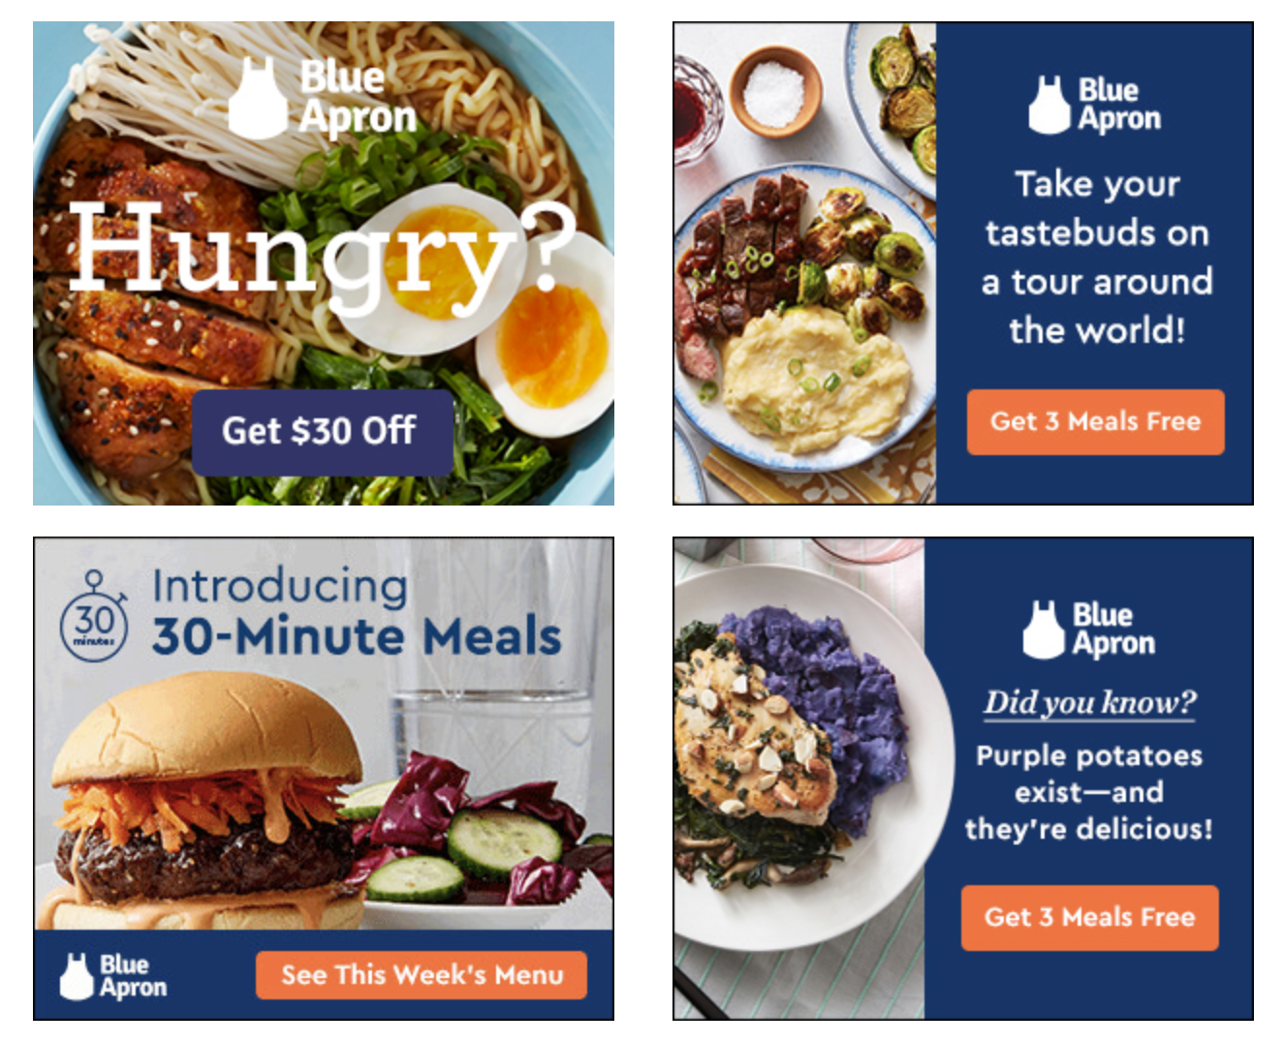

*Source: Derek Pankaew’s "An In-Depth Look At Blue Apron's $1000 Million Marketing Strategy" on MarketingStrategy.com.*

**APPENDIX B**

**Meal Kit Sponsored Search Ads**

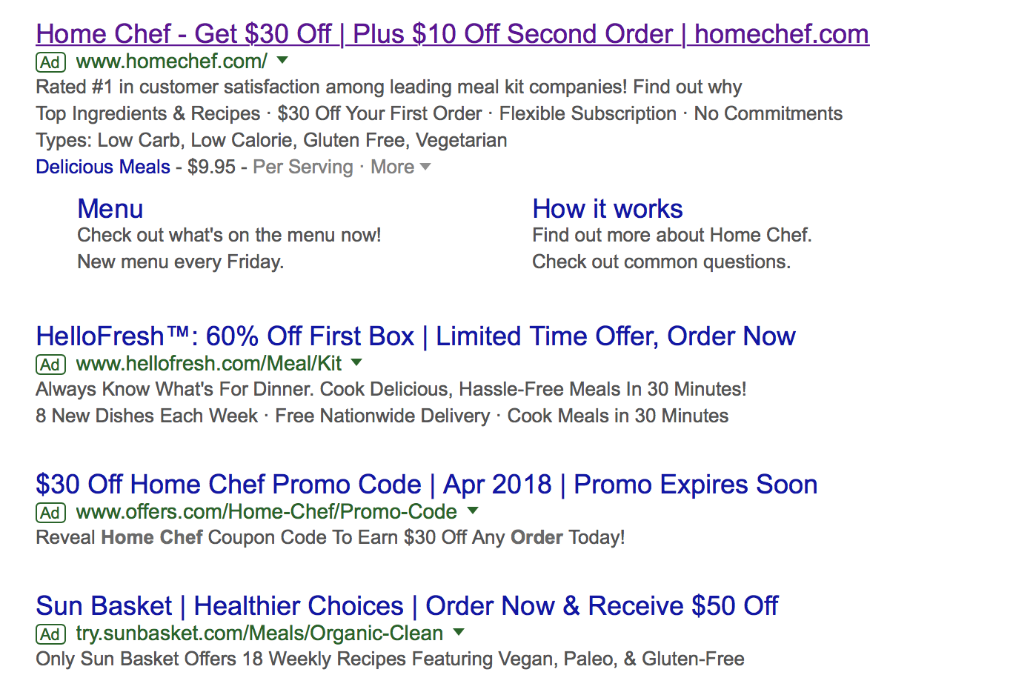

*Source: Screenshot taken by case writers of paid search advertisements appearing on Google search results for “Blue Apron.” Accessed March 30, 2018.*

**APPENDIX C**

**Customer Acquisition Economics**

**General Equation:**

Acquisition investment includes items such as media cost, sales force cost, “onboarding” cost to attach the customer to the company’s service/data systems, and incentives used to convince the customer to sign up with the company (i.e., be acquired). The relevance of these items differs by acquisition “channel”. For example, sales force costs are not relevant for the paid search channel. Below we illustrate the calculations for paid search, direct mail, and email.

**Paid Search Acquisition Economics:**

* N = number of ad exposures, i.e., the number of consumers who saw the paid search ad
* CTR = Click-through rate
* N × CTR = # of clicks, thought of as “prospects” generated by paid search
* CPC = cost per click, paid to the company that served the paid search ad, e.g., Google.
* CVR = conversion rate = fraction of prospects acquired
* I = financial incentive paid to prospects who agree to be acquired

Following the general equation,

You should review the CPC+CVR×I term. There are N × CTR clicks. Each click costs CPC. The fraction CVR of clicks are prospects who convert but must be paid an incentive that costs I. E.g., assume CPC = $6.64; CVR = 6.54%, I = $10. Then

**Direct Mail and Email**

**Overview**

**The List Industry**

Direct mail and email marketing campaigns require lists of current or potential customers who will be targets of the campaigns. Online businesses and businesses with good loyalty programs have internal lists they use for targeting current customers. The list industry provides lists for acquisition campaigns, or for companies that do not have good records of current customers.

The list industry has existed for decades and still plays an important role in customer-centric campaigns. The reason is that direct mail and email are still effective media for direct selling.

**NextMark**

NextMark is the leading online search engine for lists companies can use for specific campaigns. The search engine houses more than 100,000 lists of many kinds of customers, ranging from smartphone users to financial newsletter subscribers to seafood eaters.

The “data card” describes the list you might find on NextMark. Included is a brief description of the list, how it was assembled, when it was updated, whether it is for “snail mail” or email, etc. The price of the list is stated in $/1000. If you want to narrow down the list, you often can do so at added cost, stipulated on the data card. Sometimes lists charge extra for email addresses than for snail mail addresses. “Email” might be flagged as a “select” for an additional charge.

Typically a list is *rented* for one-time use. The marketer is not buying the list, and does not see individual names on the list. The marketer typically contracts with a third-party service company that actually sends out the campaign.

**Merge/Purge**

A standard operation before launching a direct mail or email campaign is “merge/purge”. In merge/purge, a third-party service company removes duplicate names from the list, deletes names of customers the client company does not want to target, or deletes names that are on other lists the company has rented.

For example, a company launching a customer acquisition campaign wants to send that campaign to *non-customers*, not current customers. The company provides its current customer list to the service company who removes any matches from the rented list. Another maneuver is to merge/purge two rented lists. For example, say the company has rented a list of seafood eaters but wants to run the campaign to seafood users who are not smartphone users. The company would rent the seafood eater and smartphone user lists and the service company would remove from the seafood list anyone it finds who is also on the smartphone user lists.

**Direct Mail Acquisition Economics**

* R = number of names *rented* from a direct mail list.
* RC = rental cost (per thousand names rented from a direct mail list)
* NET% = % of rented names that actually are *mailed* to (after merge/purge).
* MP = merge/purchase cost (per thousand names rented from a direct mail list)
* N = number of names actually mailed to, i.e., the # of “*prospects*” (=R × Net%).
* MC = mail cost (per thousand names *mailed* to; includes postage, printing, handling)
* I = financial incentive paid to prospects who agree to be acquired
* CVR = conversion rate (% of mailed-to prospects who sign up for service)

The conversion rate applies to the N names mailed to, (N = R ×Net%). Following the general equation:

In symbols this yields:

Note the rental and merge/purge costs apply to the names rented, while the mail costs and the conversion rate apply to the net names mailed to, the prospects. Cancelling R and collecting terms a bit in the numerator yields:

Assume RC = $150/thousand, MP = $50/1000, MC = $750/thousand, NET% = 85%, I = $10:

One could calculate CAC depending on an assumed CVR.

**Email**

* R = number of names *rented* from an email list.
* RC = rental cost (per thousand names rented from an email list)
* NET% = % of rented names that are e*mailed* to (after merge/purge).
* MP = merge/purchase cost (per thousand names rented from an email list)
* N = number of names actually emailed to, i.e., the # of “*prospects*” (=R × Net%).
* MC = emailing cost ≈ $0 (Typically a service company would send out bulk email. The cost is very low, typically 1-2 cents per email or less. We will assume $0).
* I = financial incentive paid to prospects who agree to be acquired
* CVR = conversion rate (% of emailed “prospects” who sign up for service)

The investment consists of money spent on the R names *rented* + money spent on the incentive. Following our general equation:

Quantifying this yields:

Assume RC = $200/thousand, MP = $50/1000, NET% = 85%, I = $10. We then get (note R cancels out):

One could calculate CAC depending on an assumed CVR.

Conversion rate CVR for email is sometimes calculated as %Open × %Click given open × %Convert given click. E.g., assume %Open = 17.6%; %Click given open = 14.3%[12]. %Convert given click = 10%[13] => CVR = .176 × .143 × .10 = .0025 = 0.25%.

**Appendix D**

**Retention Curve Data**

**Blue Apron**

|  |  |
| --- | --- |
| Month | % Subscribing at the Beginning of Month |
| 1 | 100% |
| 2 | 64% |
| 3 | 50% |
| 4 | 41% |
| 5 | 36% |
| 6 | 31% |
| 7 | 28% |
| 8 | 25% |
| 9 | 23% |
| 10 | 21% |
| 11 | 19% |
| 12 | 19% |
| 13 | 18% |

**HelloFresh**

|  |  |
| --- | --- |
| Month | % Subscribing at the Beginning of Month |
| 1 | 100% |
| 2 | 50% |
| 3 | 35% |
| 4 | 27% |
| 5 | 21% |
| 6 | 19% |
| 7 | 18% |
| 8 | 17% |
| 9 | 16% |
| 10 | 15% |
| 11 | 14% |
| 12 | 13% |
| 13 | 12% |

**End Notes**

1. Blue Apron. "Blue Apron Holdings Inc., Form S-1." SEC. 2017. Accessed June 20, 2018. www.sec.gov/Archives/edgar/data/1701114/000104746917003765/a2232259zs-1.htm.
2. Waxman, Howard. "Meal Kit Delivery Services in the U.S., 2nd Edition." Packaged Facts. 2017. Accessed June 20 2018. www.packagedfacts.com/Meal-Kits-Delivery-Services-Edition-10975993/.
3. Second Measure. "Blue Apron: Inside the Box." Second Measure Blog. 27 June 2016. Accessed June 20 2018. blog.secondmeasure.com/2016/06/27/blue-apron/; Blue Apron; and Waxman.
4. Second Measure. "Blue Apron? HelloFresh? Home Chef? We looked at 9 meal kits to see who steps up to the plate." Second Measure Blog. 26 October 2017. Accessed June 20 2018. blog.secondmeasure.com/2017/10/26/we-looked-at-9-meal-kits-to-see-who-steps-up-to-the-plate/; and Molla, Rami. "BlueApron still dominates the market for meal delivery kits but its market share is plummeting." Recode.net. 1 November 2017. Accessed June 20 2018. www.recode.net/2017/11/1/16581142/blue-apron-market-share-decline-meal-kit-delivery-hello-fresh.
5. Price per serving figures assume plans with three servings per week in which each serving satisfies two people and contains no specialty items. Shipping costs are included. Calories per serving varies between 500 and 700.
6. Blue Apron; and Merced, Michael J. de la. "Blue Apron, a Meal Delivery Service, Files for Public Offering." New York Times. 1 June 2017. Accessed June 20 2018. nyti.ms/2rw8QuL.
7. Pankaew, Derek. "An In-Depth Look At Blue Apron's $1000 Million Marketing Strategy." MarketingStrategy.com. 12 December 2017. Accessed June 20 2018. www.marketingstrategy.com/blue-apron-marketing-strategy/.
8. Blue Apron and McCarthy.
9. McCarhy.
10. 2016 Conversion rate = $1.10 per Euro on average.
11. Blue Apron.
12. (see <https://www.campaignmonitor.com/resources/guides/email-marketing-benchmarks/#one> )
13. (see <https://www.barilliance.com/email-marketing-statistics/#:~:text=Average%20Email%20Conversion%20Rates%20(CR)%20Statistics%20Over%20Time,-The%20first%20thing&text=The%20average%20conversion%20rate%20peaked,respectable%2015.11%25%20conversion%20in%202020> )